|  |
| --- |
| Forum post |
|  |

|  |  |  |
| --- | --- | --- |
| Large | Medium | Small |
| Total length : 28.4 cm  Short white : 0.6cm (2.1%)  Short black : 0.6 cm (2.1%)  Long white : 1.8 cm (6.3%)  Long black : 1.8 cm (6.3%) | Total length : 21 cm  Short white : 0.4cm (1.9%)  Short black : 0.4 cm (1.9%)  Long white : 1.3 cm (6.2%)  Long black : 1.3 cm (6.2%) | Total length : 14.3 cm  Short white : 0.3 cm (2.1%)  Short black : 0.3 cm (2.1%)  Long white : 0.9 cm (6.3%)  Long black : 0.9 cm (6.3%) |

Analog values analysis

|  |
| --- |
| Barcode on half A4 (no 100% accurate readings, almost impossible to decode) : |
| Starting too near the barcode (unequal speed because car accelerate poorly) |
|  |
|  |

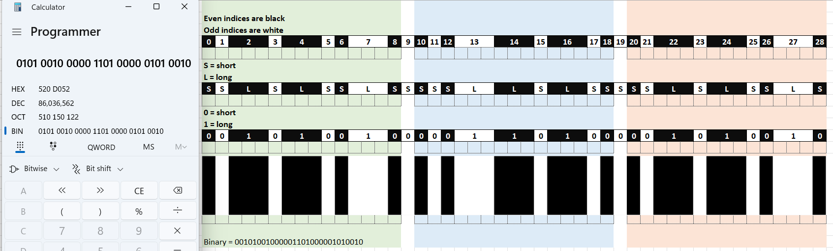

How to find the “best average” such that :

signal > average = black ?

signal < average = white?

|  |
| --- |
|  |
| Adjust true average by factors from 0.91 to 1.09 to “cut” the signals. This may not always work for the smallest barcode as sensor readings will no longer be accurate because barcodes are too small/faint for sensor to detect. Smallest barcodes need even finer or smaller sensor (nquist theorem apply here). |
| No average can be used to cut the signals for smallest barcode due to ir sensor sensitivity not fine enough to detect the small barcodes. |